Group 149

**SQL-Mongo Project – Spatial Data of US Wildfires**

**Khushboo Rathore**

|  |
| --- |
| **Activity** |
| Prepared Data Model and Created Physical DB |
| Loaded Data into Database |
| Wrote SQL Queries |
| Prepared Mongo Database |
| Loaded data into Mongo DB |
| Wrote Mongo Queries |
| Prepared Report |
| Reviewed Report |

Contents

Data Model 5

Assumptions/Notes About Data Entities and Relationships 5

Entity-Relationship Diagram 5

Physical Database 6

Assumptions/Notes About Data Set 6

Screen shot of Physical Database objects 6

Data in the Database 6

SQL Queries 7

Query 1 7

Question 7

Notes/Comments About SQL Query and Results (Include # of Rows in Result) 7

Translation 7

Screen Shot of SQL Query and Results 7

Query 2 8

Question 8

Notes/Comments About SQL Query and Results (Include # of Rows in Result) 8

Translation 8

Screen Shot of SQL Query and Results 8

Query 3 9

Question 9

Notes/Comments About SQL Query and Results (Include # of Rows in Result) 9

Translation 9

Screen Shot of SQL Query and Results 9

Query 4 10

Question 10

Notes/Comments About SQL Query and Results (Include # of Rows in Result) 10

Translation 10

Screen Shot of SQL Query and Results 10

Query 5 11

Question 11

Notes/Comments About SQL Query and Results (Include # of Rows in Result) 11

Translation 11

Screen Shot of SQL Query and Results 11

Query 6 12

Question 12

Notes/Comments About SQL Query and Results (Include # of Rows in Result) 12

Translation 12

Screen Shot of SQL Query and Results 12

Data Review for MongoDB 13

Assumptions/Notes About Data Collections, Attributes and Relationships between Collections 13

Physical Mongo Database 14

Assumptions/Notes About Data Set 14

Screen shot of Physical Database objects (Database, Collections and Attributes) 14

Data in the Database 14

MongoDB Queries/Code 15

Query 1 15

Question 15

Notes/Comments About MongoDB Query/Code and Results (Include # of Documents in Result) 15

Translation 15

Screen Shot of MongoDB Query/Code and Results 15

Query 2 16

Question 16

Notes/Comments About MongoDB Query/Code and Results (Include # of Documents in Result) 16

Translation 16

Screen Shot of MongoDB Query/Code and Results 16

Query 3 17

Question 17

Notes/Comments About MongoDB Query/Code and Results (Include # of Documents in Result) 17

Translation 17

Screen Shot of MongoDB Query/Code and Results 17

Query 4 18

Question 18

Notes/Comments About MongoDB Query/Code and Results (Include # of Documents in Result) 18

Translation 18

Screen Shot of MongoDB Query/Code and Results 18

Query 5 19

Question 19

Notes/Comments About MongoDB Query/Code and Results (Include # of Documents in Result) 19

Translation 19

Screen Shot of MongoDB Query/Code and Results 19

Query 6 20

Question 20

Notes/Comments About MongoDB Query/Code and Results (Include # of Documents in Result) 20

Translation 20

Screen Shot of MongoDB Query/Code and Results 20

Data Model

## Assumptions/Notes About Data Entities and Relationships

Include assumptions about data entities and their relationships with each other.

Include reasons why the data model is in 3NF.

**Project Assumptions:**

1. spatial_ref_sys_aux table will only have srid’s which are present in spatial_ref_sys table. There can be one or more spatial_ref_sys_aux_ID in spatial_ref_sys table.
2. For spatial_ref_sys to be in 1NF, we are breaking spatial_ref_sys_name into 2 parts: ref_sys_name_1 and ref_sys_name_2. Since as per 1NF, “There can be no multipart or multivalued fields.”
3. idx_Fires_Shape_Parent contains node number of each idx_Fires_Shape_node node number with the exception of a node which does not have any parent node number.
4. For NWCG_UnitIDActive_20170109 table to be in 3NF, we are creating Location table which contains Country, State and Code. Since as per 3NF, “No transitive dependency: every non-key column is functionally depending only on the entire primary key, and nothing else.”
5. Fires table contains many nodes from idx_Fires_Shape_node table. So there is one to many relationship between these two tables.
6. There will be zero to many relationships between Fires and FIPS table. Every FIPS code will have corresponding Object ID in Fires table but Fires table may or may not have FIPS code.
7. For every fire, there is a fire size class assigned to it. Fire class is a derived column in Fires table which can be defined from Fires_Size_Class table.
8. Every fire may or may not have a MTBS ID and one MTBS ID can be used for multiple fires, so there exists zero to many relationship between Fires and MTBS table.
9. Every fire may or may not have ICS_209_INCIDENT_NUMBER and one ICS_209_INCIDENT_NUMBER can be used for multiple fires. So there exists zero to many relationship between Fires and ICS_209 table.
10. For every fire, there is SOURCE_SYSTEM and corresponding SOURCE_SYSTEM_TYPE which is defined in Source_System table.
11. For every fire, there is SOURCE_REPORTING_UNIT and corresponding SOURCE_REPORTING_UNIT_NAME that is defined in SOURCE_REPORTING_UNIT table.
12. For every Location where the fire occurred, there is a corresponding Owner which is defined in Owner table.
13. To define cost of each fire, there is a corresponding stat_cause_code which is defined in Statistic_Cause table.
14. Every NWCG_REPORTING_ID is assigned to one or more fires and there exist corresponding NWCG_REPORTING_AGENCY and NWCG_REPORTING_UNIT_NAME.
15. DISCOVERY_DOY can be derived from DISCOVERY_DATE. Therefore we can remove DISCOVERY_DOY column from the Fires table.
16. Fire_Year can be derived from DISCOVERY_DATE. Therefore, we can remove the Fire_Year column from Fires table.
17. CONT_DOY can be derived from CONT_DATE. Therefore, we can remove the CONT_DOY column from Fires table.
18. Every spatial_ref_sys have an authority name which is defined in Authority table. One authority can be assigned to many srid.
19. There is one to many relationships between spatial_ref_sys_aux and spatial_ref_sys table.
20. Every GACC is assigned to one or more NWCG_Agency_Unit, which is defined in Geographic table.
21. We can remove redundant idx_Fires_Shape_rowid table, since it only contains information on node numbers. This column can be added to the main fires table.

## 

## Entity-Relationship Diagram

Geometric Columns –

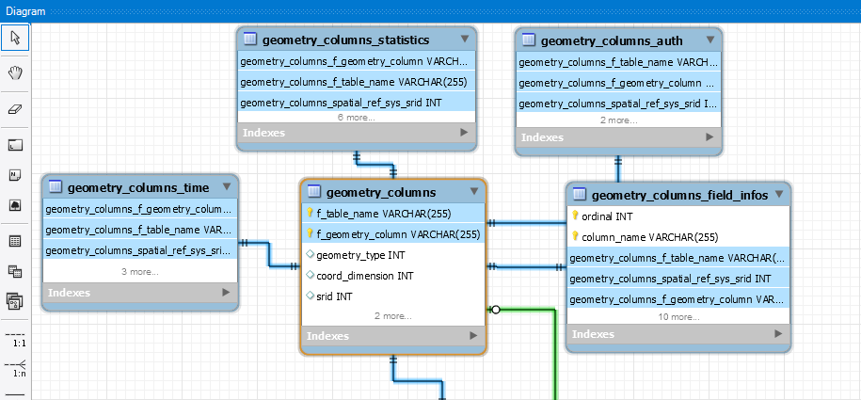

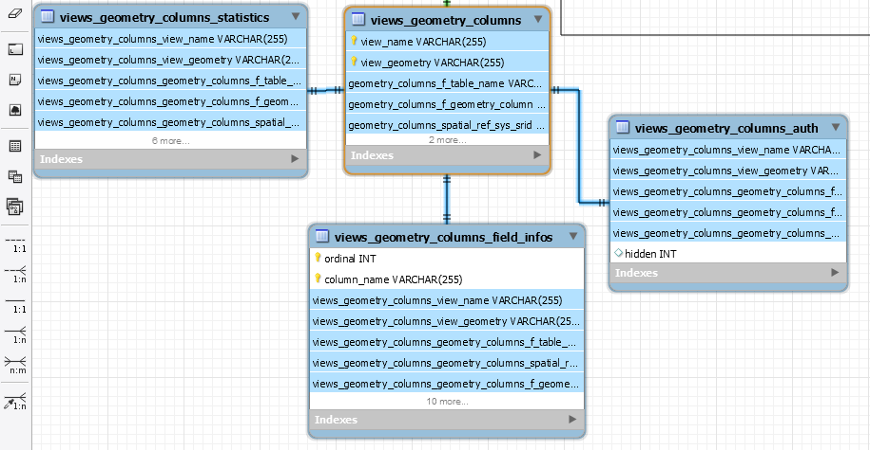

Virts_geometry –

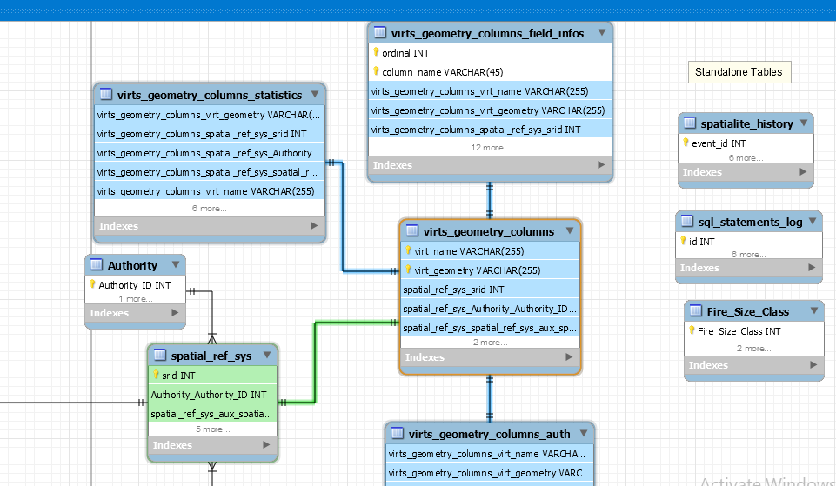

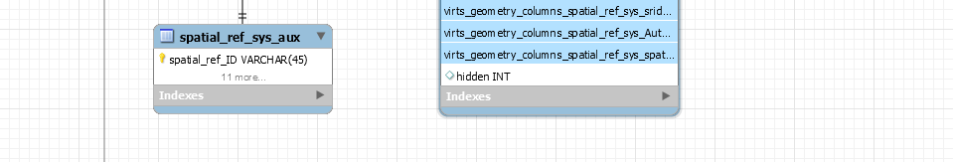

Fires –

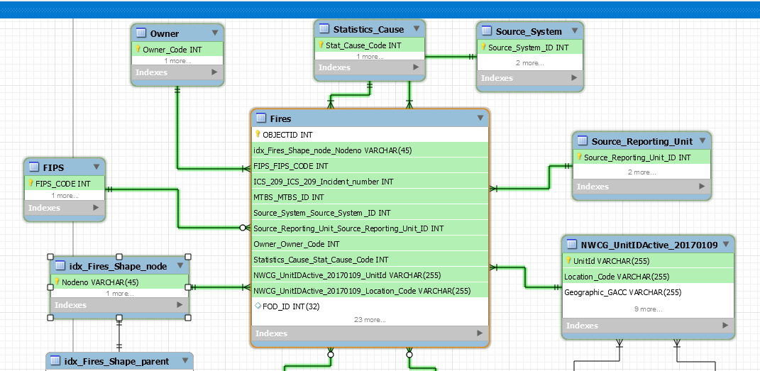

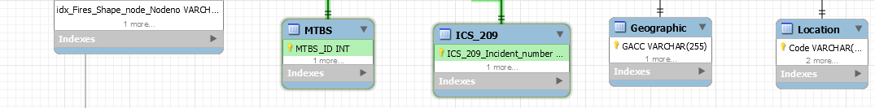

Physical Database

## Assumptions/Notes About Data Set

Include any assumptions made about data such as empty fields, sparse data, bad data, etc.

## Screen shot of Physical Database objects

## Data in the Database

|  |  |  |  |
| --- | --- | --- | --- |
| **Table Name** | **Primary Key** | **Foreign Key** | **# of Rows in Table** |
| Fires | Column (OBJECTID) |  | 1880465 |
| geometry_columns | pk_geom_cols (f_table_name, f_geometry_column) | fk_gc_srs (srid) REFERENCES spatial_ref_sys (srid) | 1 |
| geometry_columns_auth | pk_gc_aut (f_table_name, f_geometry_column) | fk_gc_auth (f_table_name, f_geometry_column) REFERENCES geometry_columns (f_table_name, f_geometry_column) ON DELETE CASCADE | 1 |
| geometry_columns_field_infos | pk_gcfld_infos (f_table_name, f_geometry_column, ordinal, column_name) | fk_gcfld_infos (f_table_name, f_geometry_column) REFERENCES geometry_columns (f_table_name, f_geometry_column) ON DELETE CASCADE | 0 |
| geometry_columns_statistics | pk_gc_statistics (f_table_name, f_geometry_column) | fk_gc_statistics (f_table_name, f_geometry_column) REFERENCES geometry_columns (f_table_name, f_geometry_column) ON DELETE CASCADE | 1 |
| geometry_columns_time | pk_gc_time (f_table_name, f_geometry_column) | fk_gc_time (f_table_name, f_geometry_column) REFERENCES geometry_columns (f_table_name, f_geometry_column) ON DELETE CASCADE | 1 |
| idx_Fires_Shape_node | nodeno |  | 72263 |
| idx_Fires_Shape_parent | nodeno |  | 72262 |
| idx_Fires_Shape_rowid | rowid |  | 1880465 |
| NWCG_UnitIDActive_20170109 | OBJECTID |  | 5867 |
| spatial_ref_sys | srid |  | 4924 |
| spatial_ref_sys_aux | srid | fk_sprefsys (srid) REFERENCES spatial_ref_sys (srid) | 4873 |
| spatialite_history | event_id |  | 16 |
| sql_statements_log | id |  | 0 |
| views_geometry_columns | pk_geom_cols_views (view_name, view_geometry) | fk_views_geom_cols (f_table_name, f_geometry_column) REFERENCES geometry_columns (f_table_name, f_geometry_column) ON DELETE CASCADE | 0 |
| views_geometry_columns_auth | pk_vwgc_auth (view_name, view_geometry) | fk_vwgc_auth (view_name, view_geometry) REFERENCES views_geometry_columns (view_name, view_geometry) ON DELETE CASCADE | 0 |
| views_geometry_columns_field_infos | pk_vwgcfld_infos (view_name, view_geometry, ordinal, column_name) | fk_vwgcfld_infos (view_name, view_geometry) REFERENCES views_geometry_columns (view_name, view_geometry) ON DELETE CASCADE | 0 |
| views_geometry_columns_statistics | pk_vwgc_statistics (view_name, view_geometry) | fk_vwgc_statistics (view_name, view_geometry) REFERENCES views_geometry_columns (view_name, view_geometry) ON DELETE CASCADE | 0 |
| virts_geometry_columns | pk_geom_cols_virts (virt_name, virt_geometry) | fk_vgc_srid (srid) REFERENCES spatial_ref_sys (srid) | 0 |
| virts_geometry_columns_auth | pk_vrtgc_auth (virt_name, virt_geometry) | fk_vrtgc_auth (virt_name, virt_geometry) REFERENCES virts_geometry_columns (virt_name, virt_geometry) ON DELETE CASCADE | 0 |
| virts_geometry_columns_field_infos | pk_vrtgcfld_infos (virt_name, virt_geometry, ordinal, column_name) | fk_vrtgcfld_infos (virt_name, virt_geometry) REFERENCES virts_geometry_columns (virt_name, virt_geometry) ON DELETE CASCADE | 0 |
| virts_geometry_columns_statistics | pk_vrtgc_statistics  (virt_name, virt_geometry) | fk_vrtgc_statistics (virt_name, virt_geometry) REFERENCES virts_geometry_columns (virt_name, virt_geometry) ON DELETE CASCADE | 0 |

Fires table loaded in the database:

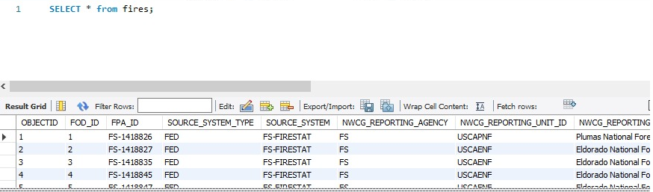

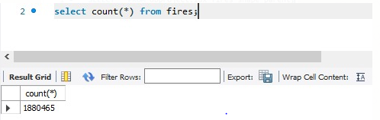

NWCG table loaded in the database :

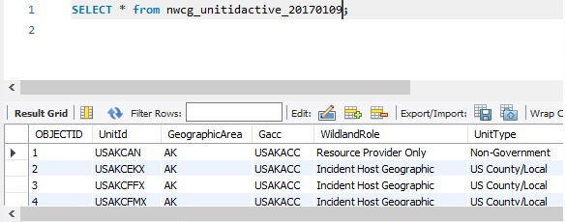

## 

IDX_FIRES_SHAPE_NODE table loaded in the database :

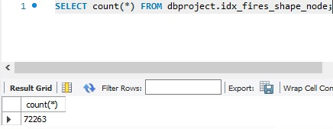

IDX_FIRES_SHAPE_PARENT table loaded in the database :

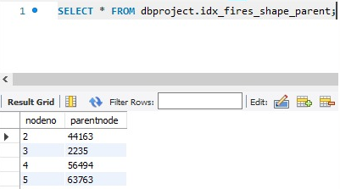

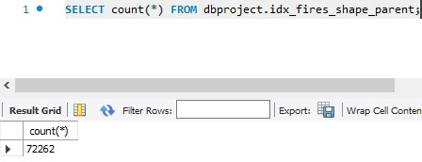

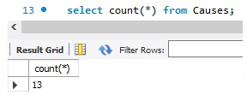

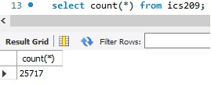

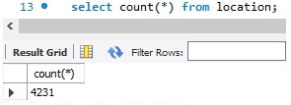

SQL Queries

## **Query 1**

### A leading beverage company has announced a billion-dollar fund for removing debris from forests, rivers and mountains in the US. All states are interested. Which 2 states have the least chance to win a share of the fund?

### **Notes/Comments About SQL Query and Results (Include # of Rows in Result)**

### SELECT Count(f.fod_ID) , f.state FROM fires f join NWCG_UnitIDActive_20170109 N ON f.NWCG_REPORTING_UNIT_ID = N.UnitId where f.stat_cause_code = "5.0" and N.country = "US" group by f.state order by count(f.fod_ID) ASC LIMIT 4

#4 number of records

### **Translation**

### Obtain the count of FOD_ID’s grouped on state from Fires table joined with NWCG_UnitIDActive_20170109 table on NWCG_REPORTING_UNIT_ID where stat_cause_code is 5 and country is US. Apply limit to filter out the two states which has the least reported cases of debris.

### **Cleanup**

Select count of FOD_ID,state from fires JOIN NWCG_UnitIDActive_20170109 on NWCG_REPORTING_UNIT_ID where f.stat_cause_code = "5.0" and N.country = "US group by state order by count(f.fod_ID) ascending LIMIT 4

### **Screenshot of SQL Query**

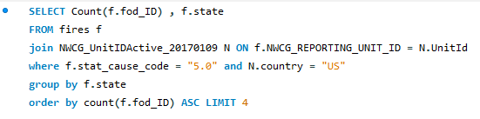

### **Screenshot of Results**

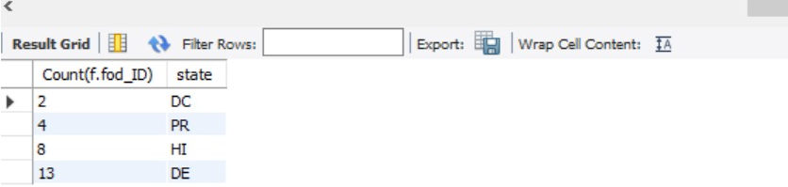

## **Query 2**

### One of the reporting agencies has suggested that children be banned from its forests unless there is one adult for every 4 children in a group visiting a forest. Name top 5 forests where this would be the least appropriate.

### 

### **Notes/Comments About SQL Query and Results (Include # of Rows in Result)**

### SELECT Count(f.fod_id), fs.source_reporting_unit_name from Fires f join Statistics_Cause s on f.stat_cause_code = s.stat_cause_code join Source_Reporting_Unit fs on f.Source_Reporting_Unit_ID = fs.Source_Reporting_Unit_ID where s.stat_cause_descr = "Children" and fs.source_reporting_unit_name like "%Forest" group by fs.source_reporting_unit_name order by count(f.fod_id) ASC LIMIT 5;

#5 number of records

### **Translation**

Select count of FOD_ID and source_reporting_unit_name from Fires table joined with Statistics_Cause table on stat_cause_code and joined with Source_Reporting_Unit on Source_Reporting_Unit_ID where stat_cause_descr is "Children" and source_reporting_unit_name contains like "%Forest" group by source_reporting_unit_name order by count(f.fod_id) ascending LIMIT 5

**Clean up**

Select count of fod_id and source_reporting_unit_name from Fires JOIN Statistics_Cause ON stat_cause_code JOIN Source_Reporting_Unit ON Source_Reporting_Unit_ID where stat_cause_descr="Children" and source_reporting_unit_name like "%Forest" group by fs. source_reporting_unit_name order by count(f.fod_id) ASC LIMIT 5

### **Screenshot of SQL Query**

### 

### **Screenshot of Results**

## 

## **Query 3**

One advocacy group says human actions and nature are equally to blame for most wildfires. Write a query that can help determine the truth of this statement.

### **Notes/Comments About SQL Query and Results (Include # of Rows in Result)**

select "Human" as "Reason", count(f.fod_id) as Count from fires f join Statistics_Cause s on f.STAT_CAUSE_CODE = s.stat_cause_code where s.Stat_Cause_Desc in ("Fireworks", "Powerline", "Structure", "Equipment Use", "Smoking", "Campfire", "Debris Burning", "Railroad", "Arson", "Children")

union

select "Nature" as "Reason", count(f.fod_id) as Count from fires f join Statistics_Cause s on f.STAT_CAUSE_CODE = s.stat_cause_code where s.Stat_Cause_Desc in ("Lightning")

### **Translation**

Select "Human" as "Reason" and obtain count of fod_id as Count from Fires table joined with Statistics_Cause on stat_cause_code where Stat_Cause_Desc contains values in ("Fireworks", "Powerline", "Structure", "Equipment Use", "Smoking", "Campfire", "Debris Burning", "Railroad", "Arson", "Children").

Select "Nature" as "Reason" and obtain count of fod_id as Count from Fires table joined with Statistics_Cause on stat_cause_code where Stat_Cause_Desc contains values in ("Lightning"). Union both the queries for combined output.

**Clean up**

Select "Human" as "Reason" and count of f.fod_id as Count from fires JOIN Statistics_Cause on stat_cause_code where Stat_Cause_Desc in ("Fireworks", "Powerline", "Structure", "Equipment Use", "Smoking", "Campfire", "Debris Burning", "Railroad", "Arson", "Children")

Union

select "Nature" as "Reason" and count of f.fod_id as Count from fires f JOIN Stat_Cause_Desc s on f.STAT_CAUSE_CODE = s.stat_cause_code where s.STAT_CAUSE_DESCR in ("Lightning")

### **Screenshot of SQL Query**

### **Screenshot of Results**

## 

## **Query 4**

### 

### Which state had fires only in the second half of the calendar years?

### 

### **Notes/Comments About SQL Query and Results (Include # of Rows in Result)**

SELECT distinct state from fires where state not in (select distinct state from fires where month(discovery_date) <= 6)

#0 number of rows

### **Translation**

Select all distinct state from Fires table which are not in the list of distinct states where month of discovery_date is less than equal to 6

**Clean up**

Select distinct(state) from Fires table where state not in (select distinct state from fires where month of discovery_date <= 6

### **Screenshot of SQL Query**

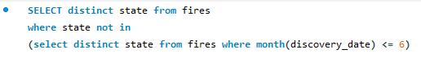

### **Screenshot of Results**

No rows found

## **Query 5**

What were the forests that had only one fire that lasted more than two days?

### **Notes/Comments About SQL Query and Results (Include # of Rows in Result)**

SELECT fs.source_reporting_unit_name, Count(f.fod_id) as "Count", (f.CONT_DATE - f.DISCOVERY_DATE) as "Duration" FROM fires f join Source_Reporting_Unit fs on f. Source_Reporting_Unit_ID= fs. Source_Reporting_Unit_ID where fs.source_reporting_unit_name like "%Forest" and (f.CONT_DATE - f.DISCOVERY_DATE > 2) group by fs.source_reporting_unit_name having Count(f.fod_id) = 1

#1 number of row

### **Translation**

Select all source_reporting_unit_name, Count all fod_id’s and calculate duration by subtracting cont_date with discovery_date from fires table joined with Source_Reporting_Unit table on Source_Reporting_Unit_ID where source_reporting_unit_name contains "%Forest" and cont_date minus discovery_date is less than 2 group by source_reporting_unit_name which is having Count of fod_id equal to 1

**Clean up**

SELECT source_reporting_unit_name, Count of fod_id as "Count", CONT_DATE minus DISCOVERY_DATE as "Duration" FROM fires join Source_Reporting_Unit on Source_Reporting_Unit_ID where source_reporting_unit_name like "%Forest" and (CONT_DATE minus DISCOVERY_DATE > 2) group by source_reporting_unit_name having Count(fod_id) = 1

### **Screenshot of SQL Query**

### 

### **Screenshot of Results**

### **Query 6**

What are the top two unit types that reported wildfires in each state in the US?

### **Notes/Comments About SQL Query and Results (Include # of Rows in Result)**

select state,agency,cnt from ( select state,agency,cnt,ROW_NUMBER()OVER(PARTITION BY state ORDER BY cnt DESC) AS Ranking from (select f.state, n.Agency, Count(1) AS cnt from fires f join NWCG_UnitIDActive_20170109 n on f.NWCG_REPORTING_UNIT_ID = n.NWCG_REPORTING_UNIT_ID where n.Agency is not Null group by f.state, n.Agency )a group by state,agency,cnt )k where k.Ranking<=2;

#103 rows returned

### **Translation**

Select all states and agencies and the count from the subquery where we are filtering the state, agency, ranking by calculating row_number by performing partition by state and order by cnt and sort descending grouped by state, agency and cnt where ranking is less that equal to 2

Obtain cnt column from fires table joined on NWCG_UnitIDActive_20170109 table on NWCG_REPORTING_UNIT_ID where agency is not null grouped by state and agency.

**Clean up**

select state,agency,cnt from ( select state,agency,cnt,ROW_NUMBER()OVER(PARTITION BY state ORDER BY cnt DESC) AS Ranking from (select state, Agency, Count(1) AS cnt from fires f join NWCG_UnitIDActive_20170109 n on f.NWCG_REPORTING_UNIT_ID = n.NWCG_REPORTING_UNIT_ID where n.Agency is not Null group by f.state, n.Agency )a group by state,agency,cnt )k where k.Ranking is less that equal to 2;

### **Screenshot of SQL Query**

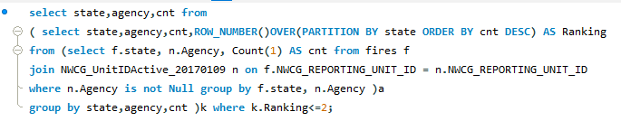

### **Screenshot of Results**

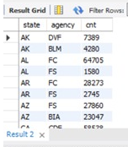

Data Review for MongoDB

## Assumptions/Notes About Data Collections, Attributes and Relationships between Collections

All collections in MongoDB are uploaded using JSON files which are exported from Mysql Normalized tables.

Physical Mongo Database

## Assumptions/Notes About Data Set

## Screen shot of Physical Database objects (Database, Collections and Attributes)

## Data in the Database:

Data is uploaded in MongoDB from json files and below collections are created -

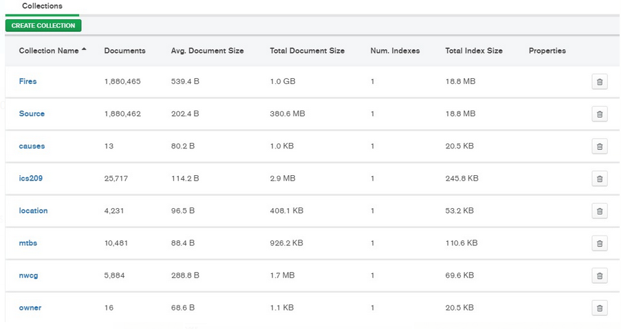

|  |  |  |
| --- | --- | --- |
| **Collection Name** | **Relationships With Other Collections (if any)** | **# of Documents in Collection** |
| Fires |  | 1,880,465 |
| Source |  | 1,880,462 |
| causes |  | 13 |
| ics209 |  | 25,717 |
| location |  | 4,231 |
| mtbs |  | 10,481 |
| nwcg |  | 5,884 |
| owner |  | 16 |

MongoDB Queries/Code

## Query 1

### Question

A leading beverage company has announced a billion-dollar fund for removing debris from forests, rivers and mountains in the US. All states are interested. Which 2 states have the least chance to win a share of the fund?

db.fires.aggregate([

{

$lookup: {

from: "NWCG",

localField: "State",

foreignField: "State",

as: "fromStates"

}

},

{

$replaceRoot: { newRoot: { $mergeObjects: [ { $arrayElemAt: [ "$fromStates", 0 ] }, "$$ROOT" ] } }

},

{ $match : { $and: [ { "Country": "US" }, { "STAT_CAUSE_CODE": "5.0" } ] } },

{ $group : {_id : {State: "$State"}, Fcount: { $sum: 1}}},

{$sort :{Fcount:1}},

{$limit:4}

]);

### Notes/Comments About MongoDB Query/Code and Results (Include # of Documents in Result)

In this question, STAT_CAUSE_CODE for debris is 5.0 and we need to check for country USA. We checked the count state wise and found 2 states which have the least chance to win a share of the fund. Here we have shown 4 rows since the least 2 states i.e. DC and PR.

### Translation

### Screen Shot of MongoDB Query/Code and Results

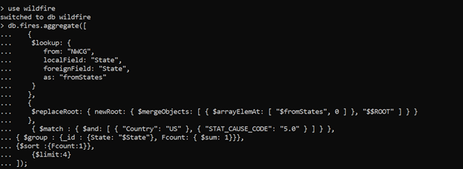

Output Snapshot:

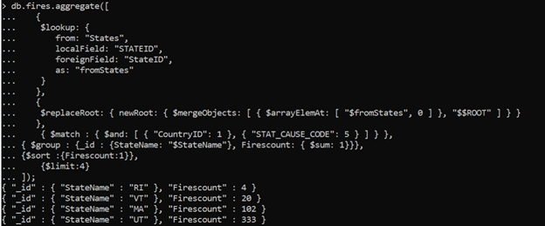

# of documents returned: 4

## Query 2

### Question

One of the reporting agencies has suggested that children be banned from its forests unless there is one adult for every 4 children in a group visiting a forest. Name the top 5 forests where this would be the least appropriate.

### Notes/Comments About MongoDB Query/Code and Results (Include # of Documents in Result)

db.fires.aggregate([

{

$lookup: {

from: "causes",

localField: "STAT_CAUSE_CODE",

foreignField: "STAT_CAUSE_CODE",

as: "fromCause"

}

},

{

$replaceRoot: { newRoot: { $mergeObjects: [ { $arrayElemAt: [ "$fromCause", 0 ] }, "$$ROOT" ] } }

},

{

$lookup: {

from: "Source",

localField: "FPA_ID",

foreignField: "FPA_ID",

as: "fromSource"

}

},

{

$replaceRoot: { newRoot: { $mergeObjects: [ { $arrayElemAt: [ "$fromSource", 0 ] }, "$$ROOT" ] } }

},

{ $match : { $and: [ { "STAT_CAUSE_DESCR": "Children" }, { "SOURCE_REPORTING_UNIT_NAME": /$Forest$/ } ] } },

{ $group : {_id : {SOURCE_REPORTING_UNIT_NAME: "$SOURCE_REPORTING_UNIT_NAME"}, Fcount: { $sum: 1}}},

{$sort :{Fcount:1}},

{$limit:5}

]);

### Translation

In this question, we checked STAT_CAUSE_DESCR for Children and we need to check for country USA. We checked the count state wise and found 5 states which have SOURCE_REPORTING_UNIT_NAME like forests where this would be the least appropriate.

### Screen Shot of MongoDB Query/Code and Results

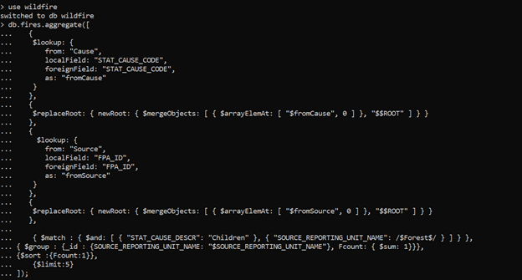

Output:

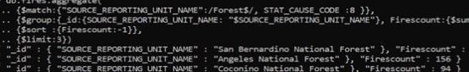

# of documents returned: 5

## Query 3

### Question

One advocacy group says human actions and nature are equally to blame for most wildfires. Write a query that can help determine the truth of this statement.

### Notes/Comments About MongoDB Query/Code and Results (Include # of Documents in Result)

db.fires.aggregate([

{

$lookup: {

from: "causes",

localField: "STAT_CAUSE_CODE",

foreignField: "STAT_CAUSE_CODE",

as: "fromCause"

}},

{

$replaceRoot: { newRoot: { $mergeObjects: [ { $arrayElemAt: [ "$fromCause", 0 ] }, "$$ROOT" ] } }

},

{

$match: { "STAT_CAUSE_DESCR": {$in: ["Fireworks","Powerline","Structure", "Equipment Use", "Smoking", "Campfire", "Debris Burning", "Railroad", "Arson", "Children"]}}

},

{ $group : {_id : {STAT_CAUSE_DESCR: "$STAT_CAUSE_DESCR"}, Fcount: { $sum: 1}}},

]).pretty();

db.fires.aggregate([

{

$lookup: {

from: "Cause",

localField: "STAT_CAUSE_CODE",

foreignField: "STAT_CAUSE_CODE",

as: "fromCause"

}},

{

$replaceRoot: { newRoot: { $mergeObjects: [ { $arrayElemAt: [ "$fromCause", 0 ] }, "$$ROOT" ] } }

},

{

$match: { "STAT_CAUSE_DESCR": ["Lightning"]}}

},

{ $group : {_id : {STAT_CAUSE_DESCR: "$STAT_CAUSE_DESCR"}, Fcount: { $sum: 1}}},

]).pretty();

### Translation

In this scenario, here we found first what are STAT_CAUSE_DESCR which are caused by nature i.e. Lightning and STAT_CAUSE_DESCR which are caused by human i.e. Fireworks, Powerline, Structure, Equipment Use, Smoking, Campfire, Debris Burning, Railroad, Arson and Children. Then we compared number of fires caused by both. And then after comparing the count we found that human actions are more to blame for most wildfires as compared to nature.

### Screen Shot of MongoDB Query/Code and Results

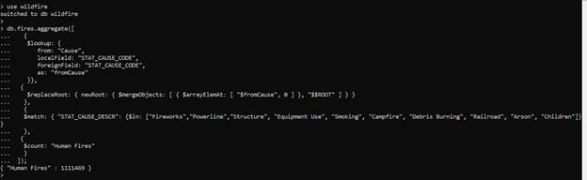

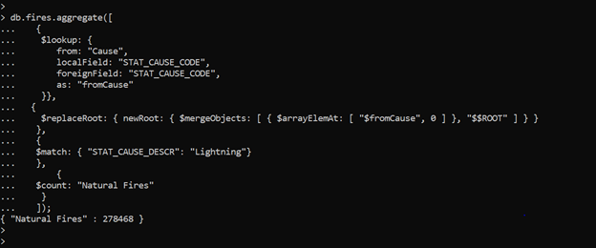

# of documents returned: For Human Fires: 1111469 , For Natural fires: 278468

## Query 4

### Question

How many wildfires were reported by at least two units/agencies?

### Notes/Comments About MongoDB Query/Code and Results (Include # of Documents in Result)

db.fires.aggregate([

{$project:{FIRE_NAME:1,SOURCE_REPORTING_UNIT:1}},

{$group: {_id:"$FIRE_NAME",No_of_units_reported: {$sum: "$SOURCE_REPORTING_UNIT"}}},

{$match: {No_of_units_reported:{$gte:2}}}

]).toArray().length;

### Translation

In this scenario, we checked that No_of_units_reported which are greater than 2 for each fire and we grouped it by FIRE_NAME and we found that the number of wildfires reported by at least two agencies.

### Screen Shot of MongoDB Query/Code and Results

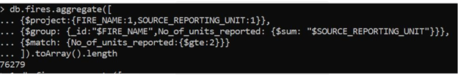

# of documents returned: 76279

## Query 5

### Question

Which state had fires only in the second half of the calendar years?

### Notes/Comments About MongoDB Query/Code and Results (Include # of Documents in Result)

### Translation

In this scenario, we are checking those states which have discovery day of year is less than 180 days.

so in this case we found all 52 states are there where fires occurred in both the first half and second half of the year so there is no row returned for states in only the second half of the year.

### Screen Shot of MongoDB Query/Code and Results

db.fires.aggregate([

{ "$match": {

"STATE": {

"$nin": db.fires.distinct("_id",{ $lte: [ "DISCOVERY_DOY": "180" ]})

}

}}

]);

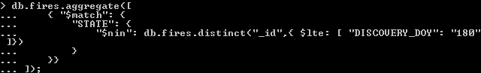

# of documents returned: 0

## Query 6

### Question

What were the forests that had only one fire that lasted more than two days?

### Notes/Comments About MongoDB Query/Code and Results (Include # of Documents in Result)

db.fires.aggregate([

{$match : { $and: [ { "SOURCE_REPORTING_UNIT_NAME":/Forest$/}, { "CONT_DOY": { $not: / / } }, { "CONT_DOY-DISCOVERY_DOY": { $not: /0/ } }, { "CONT_DOY-DISCOVERY_DOY": { $not: /1/ } },

{"CONT_DOY-DISCOVERY_DOY": { $not: /2/ } },{"CONT_DOY-DISCOVERY_DOY": { $not: /-363/ } },{"CONT_DOY-DISCOVERY_DOY": { $not: /-364/ } } ] } },

{ $group: {_id: {SOURCE_REPORTING_UNIT_NAME: "$SOURCE_REPORTING_UNIT_NAME"}, Firescount: { $sum: 1}}},

{ $match: { Firescount: { $gte: 2} } },

{$sort :{Firescount:-1}}

]);

### Translation

In this scenario, we checked that SOURCE_REPORTING_UNIT_NAME like Forest and where CONT_DOY is not NULL, and difference between CONT_DOY and DISCOVERY_DOY should not be equal to 0, 1, 2, -363 and -364 and grouped it by SOURCE_REPORTING_UNIT_NAME and such Firescount should be greater than equal to one.

### Screen Shot of MongoDB Query/Code and Results

